# Scratch logo and symbol, meaning, history, PNG

**Scratch Invaders 3**

Register/login at <https://scratch.mit.edu>

*The invaders shoot back.*

1. Download *invader* images from:  
   <https://codeclub67.github.io/images/invader.gif>
2. Create a new sprite by uploading the *invader* images.
3. Rename it as “**bomb**” and select the zig-zag costume.

**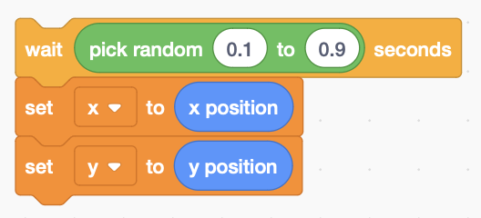***Only one bomb is in play at any time, dropped randomly by any invader.*

1. 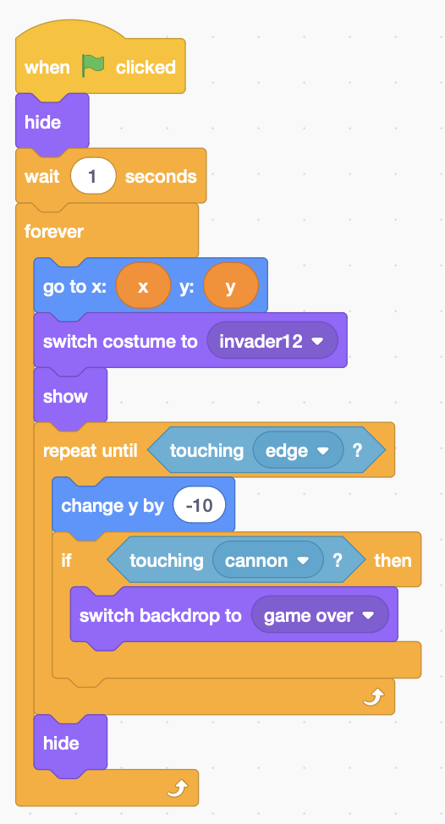Add invader code at the end of each step (inside the check that it’s a clone) to record its x & y position, but after a random time less than 1 second.

*The bomb uses the latest x,y coordinates.*

1. The bomb goes to the invader x,y then starts falling (**change y**) until it **touches** the bottom edge.
2. If the bomb **touches** the **cannon** then the game is over.

*Remember to* ***Save*** *your code.*